Ka Malama `Anela 702-900-7189
Kilani Pedro, L.M.T. LIC# NVMT 8362 www.HuiOAnela.com
Certified Angel Intuitive, Kahuna, CACR, CATR Kahuna@HuiOAnela.com

Client Intake Form:
Name Cell # Home #

Address

Email Address Date of Birth

Years / Months
Relation
Occupation
Emergency Contact
Phone #

The following information will be used to design safe and effective massage sessions. Please answer the questions to the best of your knowledge. Your answers will be discussed at the start of each session.
Date of Initial Visit Referred By

- Have you had a professional massage before? Yes No If
If yes, how often do you receive massage therapy?
- Do you have any difficulty lying on your front, back, or side? Yes No If yes, please explain ________________________________________________
Yes No
- Do you have any allergies to oils, lotions, ointments, holistic herbs or scents? If yes, please explain
- Do you have sensitive skin? Yes No
- Are you wearing contact lenses ( ) dentures ( ) hearing aid(s) ( )?
- Do you sit for long hours at a workstation, computer, or driving? Yes If yes, please describe | No  No
- Do you perform repetitive movements with work, sports, or hobbies? If yes, please describe | Yes
- Do you experience stress in your work, family, or other aspect of your life? | Yes | No
If yes, how do you think it has affected your health?
What type of massage are you seeking (select all that apply)? Relaxing Angel Intuitive CranioSacral Sports
Trigger Point Clinical Bodywork (Myofascial Repatterning) Reflexology Reiki / Energy I’m undecided
What pressure do you prefer? Deep / Trigger Point Medium Light Energy work
Any areas of the body where you are experiencing tension, stiffness, pain or other discomfort? Yes No
If yes, please identify __________________________________________________________________________________
Do you have any particular goals in mind for this angel intuitive massage session? Yes No
If yes, please share ___________________________________________________________________________________
Are there any areas (face, abdomen, feet, etc.) you do not want massaged? _________________________________________
Muscle Tension ( ) Anxiety ) Insomnia ( ) Irritability Other

Ka Malama `Anela 702-900-7189
Kilani Pedro, L.M.T. LIC# NVMT 8362 www.HuiOAnela.com
Certified Angel Intuitive, Kahuna, CACR, CATR Kahuna@HuiOAnela.com

Medical History:
- Are you currently seeing a medical practitioner or chiropractor? Yes No
  - If yes, please explain _________________________________________________________________________________
- Are you currently taking any medication? Yes No
  - If yes, please list ____________________________________________________________________________________
- Please circle all that applies to you :
(
(

Anxiety / Depression / Stress / PTSD
*Recent / current fever
Swollen glands
Fatigue / Anemia
Bruise easily / Hemophilia
Open sores / wounds
*Recent fracture / strain / sprain
Neck / back pain or injury
Leg / knee pain or injury
Jaw clenching / Teeth grinding
Joint disorder / Tendonitis
Surgeries (in the last 18 months)
Allergies / Skin or other sensitivities
Breathing problems / Asthma
Arteriosclerosis / Atherosclerosis
Varicose Veins / Phlebitis
Deep Vein Thrombosis / Blood clots
Headaches / Migraines
Epilepsy / Seizures
Diabetes / Neuropathy
Fibromyalgia / Multiple Sclerosis
Cancer
Other ______________________________
*Recent = within the last two weeks ____________________
Contagious skin condition
Heart condition
High or low blood pressure
Decreased sensation
Carpal Tunnel Syndrome
Tennis Elbow / Golfer’s Elbow
Scoliosis / Lordosis / Kyphosis
Sciatica / Pseudo-Sciatica
TMJS / TMD (Jaw pain)
Rheumatoid Arthritis / Osteoarthritis
Artificial Joint / Pins / Plates / Pacemaker
Pregnant ~ wks. / mos.? ____________

Please explain the circled conditions above ______________________________________________________________________________

- Do you drink alcohol or take recreational drugs? Yes No ~ If yes, has it been more than 48 hours? Yes No
Kilani Pedro DBA Ka Malama `Anela and Hui O `Anela invites you to ask any questions regarding all available products and services. The most effective therapeutic massage will comprise of the mutual understanding, trust, and compassion shared between a massage therapist and client.
Full payment is required for all services rendered prior to session. All services and products may be securely purchased prior to any session online by visiting www.HuiOAnela.com. If web access is not available, cash, debit, or credit card may be accepted beforehand. Tips are appreciated.
**NO REFUNDS ON ALL SERVICES. NO EXCEPTIONS. **
Please be available (20) twenty minutes before your session for paperwork, payment, and table set-up/session preparations. .

Please mark areas of discomfort with an X and
CIRCLE areas you would like to focus on.
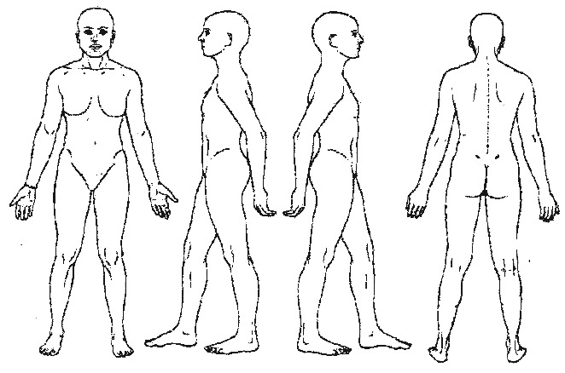
I authorize Ka Malama `Anela to release all information requested, in writing, by/to my medical provider, clinic, or hospital. Otherwise, I understand that my private health information is protected under HIPAA: www.hhs.gov/hipaa/

I agree to keep my massage therapist informed of changes to my medical profile and will update my file of these changes. Since massage should not be performed with certain medical conditions, medications or while under the influence, I affirm that I have answered all questions to the best of my knowledge and stated all known medical conditions. I also accept my responsibility in communicating my comfort level throughout the session. I understand that there shall be no liability on the massage therapist’s part should I fail to do any of the above. I have read, understand, and agree to all the terms and policies provided to me.

___________________________________________________ ______________________________________ __________________________________
Client’s Signature of Acknowledgement Print Name Date

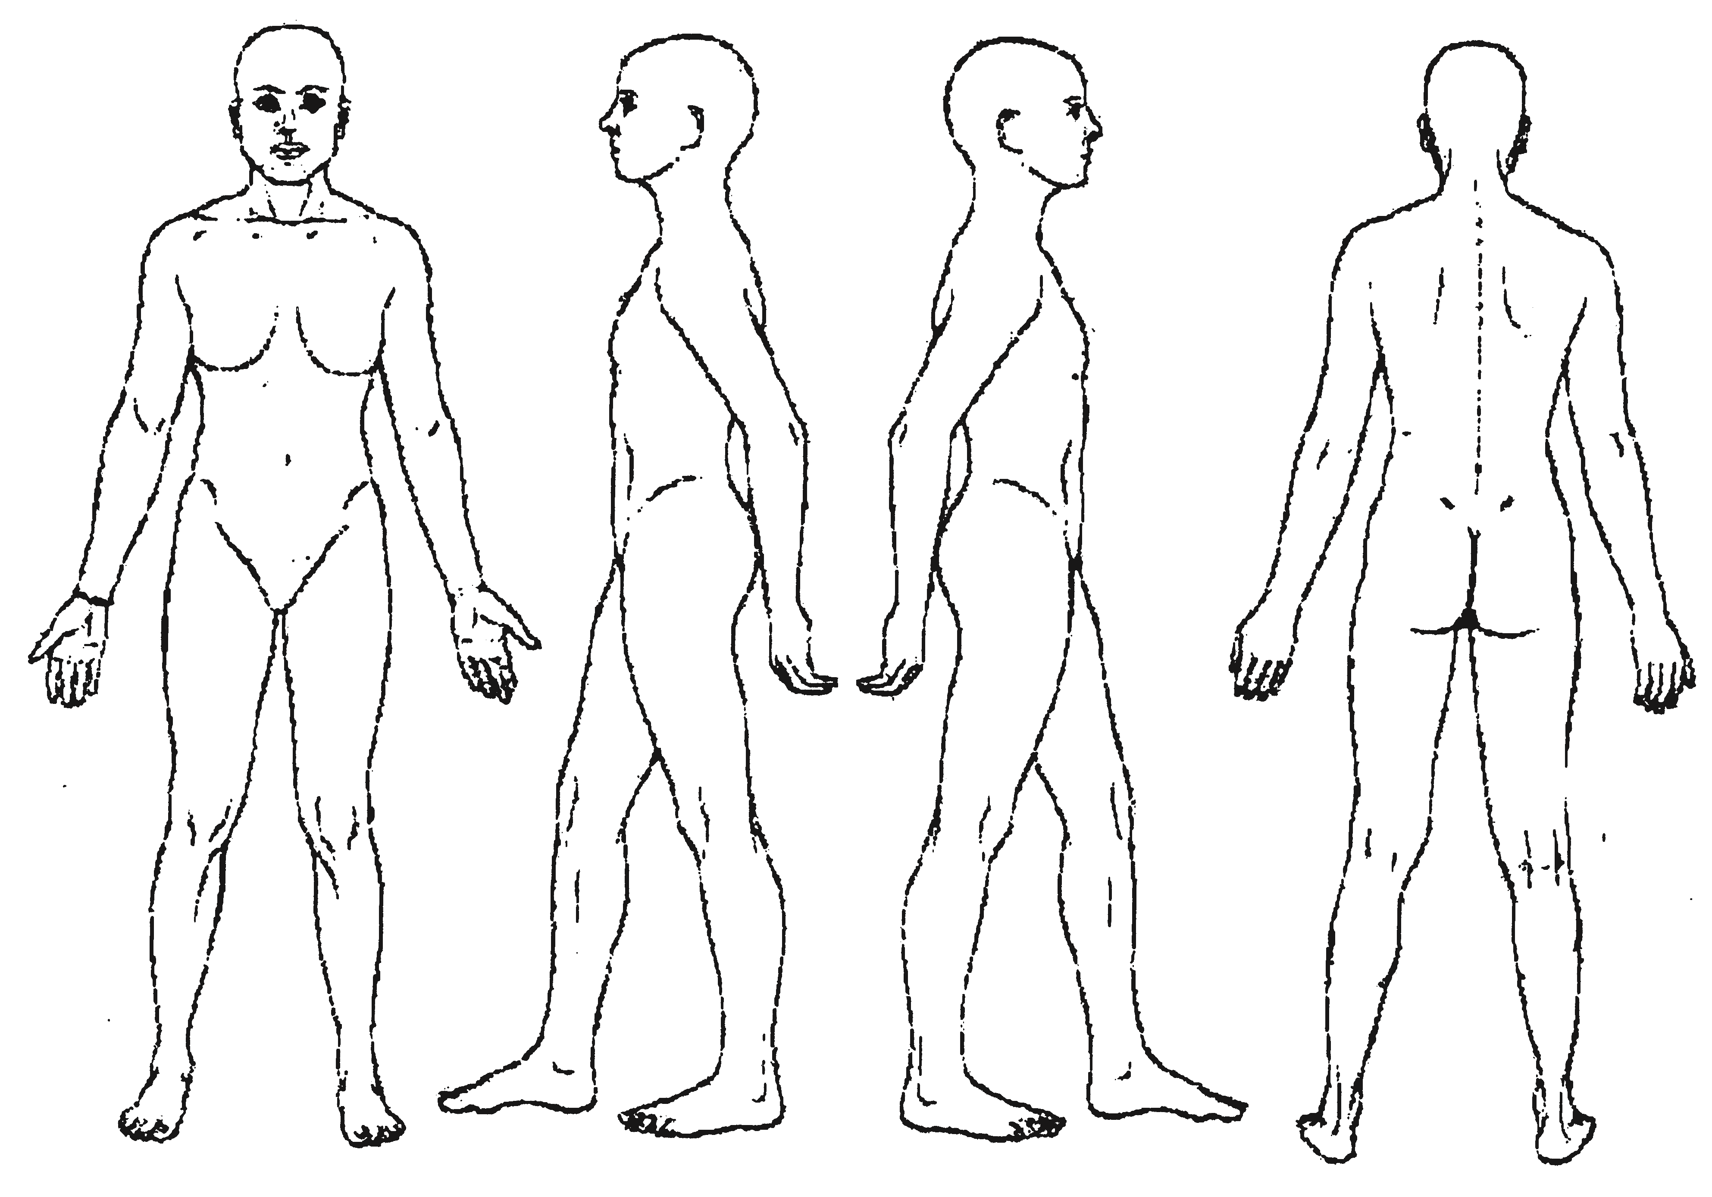
If yes, please explain
Cir
cle any specific ar
eas you would like the
Massage therapist to concentrate on
During the session:
Continued on page 2

